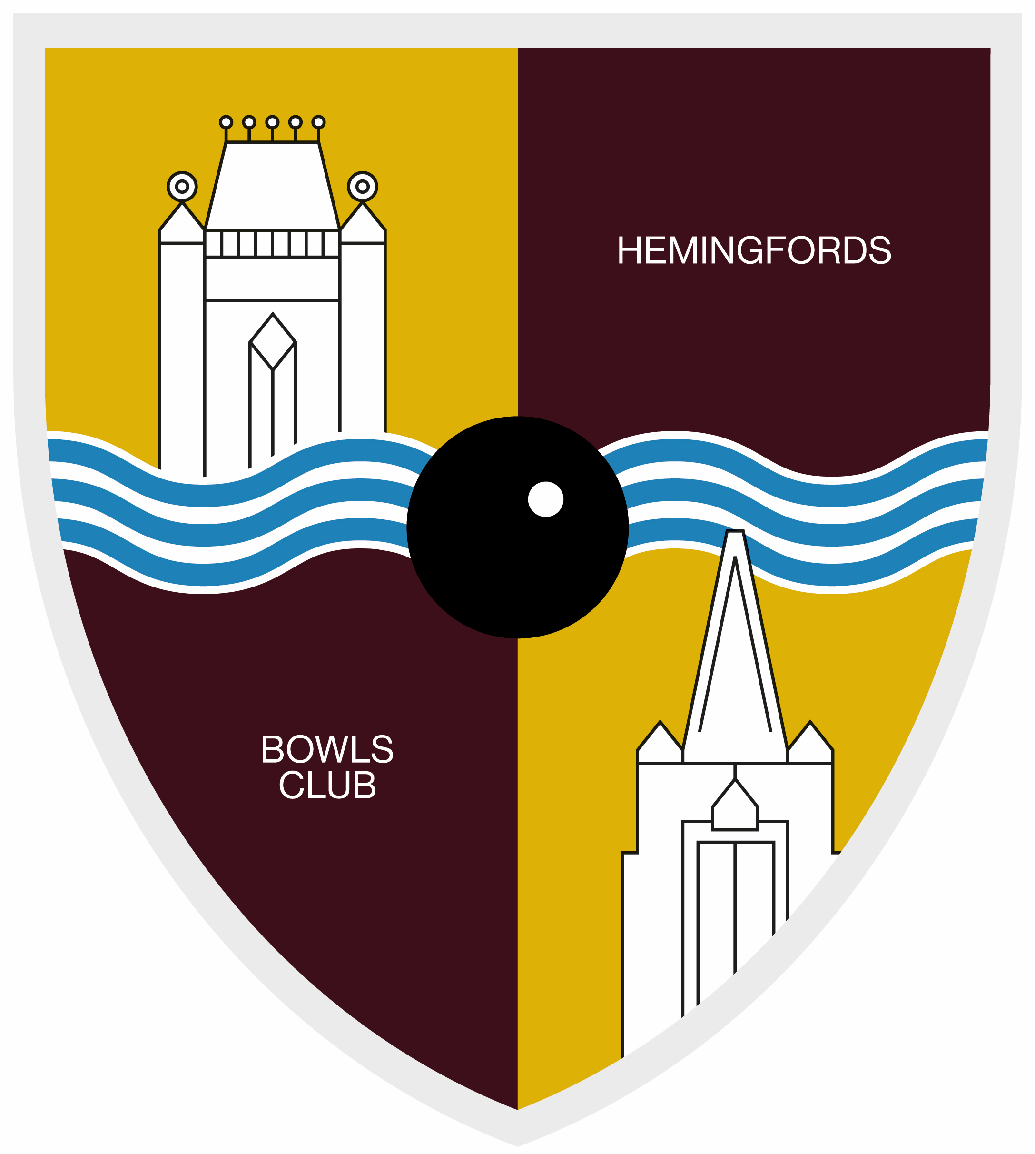
THE HEMINGFORDS BOWLS CLUB
PRIVACY NOTICE

The Hemingfords Bowls Club (hereafter ‘the Club’) respects your right to privacy. As part of our commitment to protect your privacy, we have produced this notice to explain what personal data we hold and how we use it. We also want to make you aware of your rights under the General Data Protection Regulation (GDPR). Our aim is to be fair and transparent about how we use your personal data, in order to foster greater trust between the Club and yourself.

What personal data we hold and why
When you sign up as a member of the Club, you provide us with personal data on your membership form. The personal data will include your
- personal contact details that allows us to contact you directly such as name, title, postal and email addresses, telephone numbers;
- gender;
- date of birth (not mandatory except where age restricted competition entry requires it)
- membership start and end date;
- records of your interactions with us such as telephone conversations, emails and other correspondence and your instructions to us;
- details of the financial transactions with you;
- use of and movements through our online portal, passwords, personal identification numbers, IP addresses, user names and other IT system identifying information;
- records of your attendance at any events hosted by us;
- images in video and/or photographic form;
- details of any county bowls membership;
- records and assessment of any player rankings, grading or ratings, competition results, details regarding events/matches/games attended and performance
- any disciplinary and grievance information.
This is predominately the only personal information we hold. We may ask for health information and/or Emergency Contact details (provided voluntarily i.e. not a mandatory requirement), which are classed as ‘Special Category Data’ and requires greater protection, because of its sensitive nature.

How do we collect this personal information?
We typically collect personal information about our members when you apply to become a member of the club or you request an account with us via the website www.hemingfordbowls.co.uk, when you make a query and/or complaint or when you correspond with us by phone, e-mail or in some other way.

How we use your personal data
The GDPR requires organisations to justify why they use your personal data and specify which of the six ‘Lawful Basis for Processing’ they are assigning to each task.

Membership and Club Management
- Registering and administering your membership.
- Informing you of statutory items, such as AGM notices.
- Informing HMRC of ‘Gift-Aid’ donations.
The lawful basis for processing is Legal Obligation and Contract.

Matches and Competitions
- Sharing contact details with club captains, vice-captains or team managers to help manage team selection for matches.
- Sharing contact details with opponents/ fellow bowls clubs to help arrange competitions.
- Sharing contact details with internal league organisers.
- Sharing contact details with other members via the Club fixture card.
The lawful basis for processing is Legitimate Interests. You can ask for details not to be shared, but this would make it difficult for your inclusion in matches and competitions.

Social Activities
- Sending information on Club events, such as social evenings and club competitions.
- Sending information on Club news, such as members’ successes.
The lawful basis for processing is Consent. You will not receive these communications automatically and will need to let the Club know that you wish to receive them (opt-in). You can choose to stop receiving these communications by informing the Club.

Who we share your personal data with
If you have joined as a playing member, not a social member, we are required to forward your name and email to Bowls England via Huntingdonshire Bowls; Huntingdonshire Bowling Federation, Huntingdonshire Women’s Bowling Federation; Huntingdon & District Bowls League, Huntingdonshire Ladies League. This is to validate your affiliation to the respective County associations, Leagues and the National governing body – Bowls England. For further information of how your data is used by these organisations, please refer to their Privacy Notices.
If you enter a Huntingdon and District, Huntingdonshire or National competition, we will also forward your telephone number and age if entered for an age-related competition.
The Club has Social Media groups on Facebook. We do not pass your details on to this service. The personal data you provide to this service will be governed by their own Privacy Policies. If you have concerns over your personal data, you should contact the service as the Data Controller.
We do not share your personal data outside of the UK.

How long we keep your personal data
We will hold onto your personal data for as long as you are a member of the Club. Some records may be held for longer, such as records submitted to HMRC, but will be securely destroyed after seven years.
The data stored is reviewed annually. Old and incorrect data is deleted from the system and from any backups

How do we store your personal data
We have in place a range of security safeguards to protect your personal information against loss or theft, as well as unauthorised access, disclosure, copying, use, or modification.
Your data is held by one or more of the following methods:
- On a computer based system held by Gareth Evans, the Club Secretary and Superuser, Sue Peel the Club Chair and Superuser, Eamonn Byrne the Club Treasurer.
- On a paper based filing system held by Gareth Evans, the Club Secretary, Eamonn Byrne the Club Treasurer.
- The Club’s website, provided by a third party, which stores personal data (match results) and pictures. [hemingfordbowls.co.uk]. If you have concerns over your details, you should contact the Club as the Data Controller.

Special category data
We may collect health data on medical conditions and emergency contact details for your safety at the Club. This information is securely held and is not available to the public. It is optional whether you provide these details.

Children
We collect additional information on parents and/ legal guardians in line with our Safeguarding Policy. We never disclose the child’s details without the prior consent of the parents.

Your rights to control your personal data
The GDPR provides you with a number of rights over your personal data. At any time you can:
- Request information about how the Club handles your personal data.
- Request your details to be updated or deleted.
- Submit a ‘Subject Access Request’ (SAR), which will require the Club to provide you with specific details about how and where your details have been used.
- Restrict or object to the way your details are used, such as opting-out of the Club’s communications.

Availability and changes to this policy
This policy is available online at www.hemingfordbowls.co.uk. This policy may change from time to time. If we make any material changes we will make members aware of this via email/ club newsletter / at Meetings/ on Notice Boards.

How to complain
If you are not happy with the way the Club has handled your data privacy, you can complain to the Information Commissioner’s Office (ICO). They are the UK’s Data Protection watchdog or ‘Supervisory Authority’. You can submit a complaint via https://ico.org.uk/concerns/ or call 0303 123 1113.

Contact us
If you have any questions about the Club’s privacy policy or practices, please contact either:
secretary@hemingfordbowls.co.uk or sue@hemingfordbowls.co.uk

Approval by Chairperson on behalf of the Committee of The Hemingford Bowls Club following submission and approval at the meeting held on
Date 08.04.2026
Signed S M Peel Chairperson

APPENDIX
The table below describes the main purposes for which we process your personal information, the categories of your information involved and our lawful basis for being able to do this.
Purpose | Personal information used | Lawful basis
To administer any membership you have with us and managing our relationship with you, including dealing with payments and any support, service or product enquiries made by you | All contact and membership details, payment information, records of your interactions with us. | This is necessary to enable us to properly manage and administer your membership contract with us.
To arrange and manage any contracts for the provision of any services or products | Contact details, transaction and payment information.  Records of your interactions with us. | This is necessary to enable us to properly administer and perform any contract for the provision of any services and products you have purchased from us.
To send you information which is included within your membership, including details about competitions and events, and any updates on bowls | Contact and membership details. | This is necessary to enable us to properly manage and administer your membership contract with us.
To send you information you have requested from us, including our newsletters, information about membership, events, and products e.g. shirts | Contact details. | Where you have given us your explicit consent to do so
To answer your queries or complaints | Contact details and records of your interactions with us | We have a legitimate interest to provide complaint-handling services to you in case there are any issues with your membership.
To enter members into age restricted competitions organised by County and National Bowling Associations | Date of Birth | We are required to comply with National and County age restrictions when verifying Member entry forms for certain competitions e.g. Under 25, Over 55, Over 60 age categories.
To conduct data analytics studies to understand event attendance | Records of your attendance at any events or competitions hosted by us. | We have a legitimate interest in doing so to ensure that our membership is targeted and relevant.
Retention of records | All the personal information we collect. | We have a legitimate interest in retaining records whilst they may be required in relation to complaints or claims. We need to retain records in order to properly administer and manage your membership and run our club and in some cases we may have legal or regulatory obligations to retain records.  Where we process special category personal data on the basis of the “special category reasons for processing of your personal data” referred to in section 2 above. We will only retain for the period when it is relevant
The security of our IT systems | Your usage of our IT systems and online portals. | We have a legitimate interest to ensure that our IT systems are secure.
For the purposes of promoting the club, our events and membership packages | Images in video and/or photographic form. | Where you have given us your explicit consent to do so.
To arrange for any trip or transportation to and from an event | Identification documents details of next of kin, and emergency contacts, payment information, health and medical information. | This is necessary to enable us to make the necessary arrangements for the trip and/or transportation to an event.  We process special category personal data on the basis of the “special category reasons for processing of your personal data” referred to in section 2 above.  If any information required falls into this category we would ask your explicit consent
To gather evidence for possible grievance or disciplinary hearings | All the personal information we collect | We have a legitimate interest in doing so to provide a safe and fair environment for all members and to ensure the effective management of any disciplinary hearings, appeals and adjudications.  If this includes special category personal data on the basis of the “special category reasons for processing of your personal data” referred to in section 2 above we would ask your explicit consent  For criminal records history we process it on the basis of legal obligations or based on your explicit consent.

