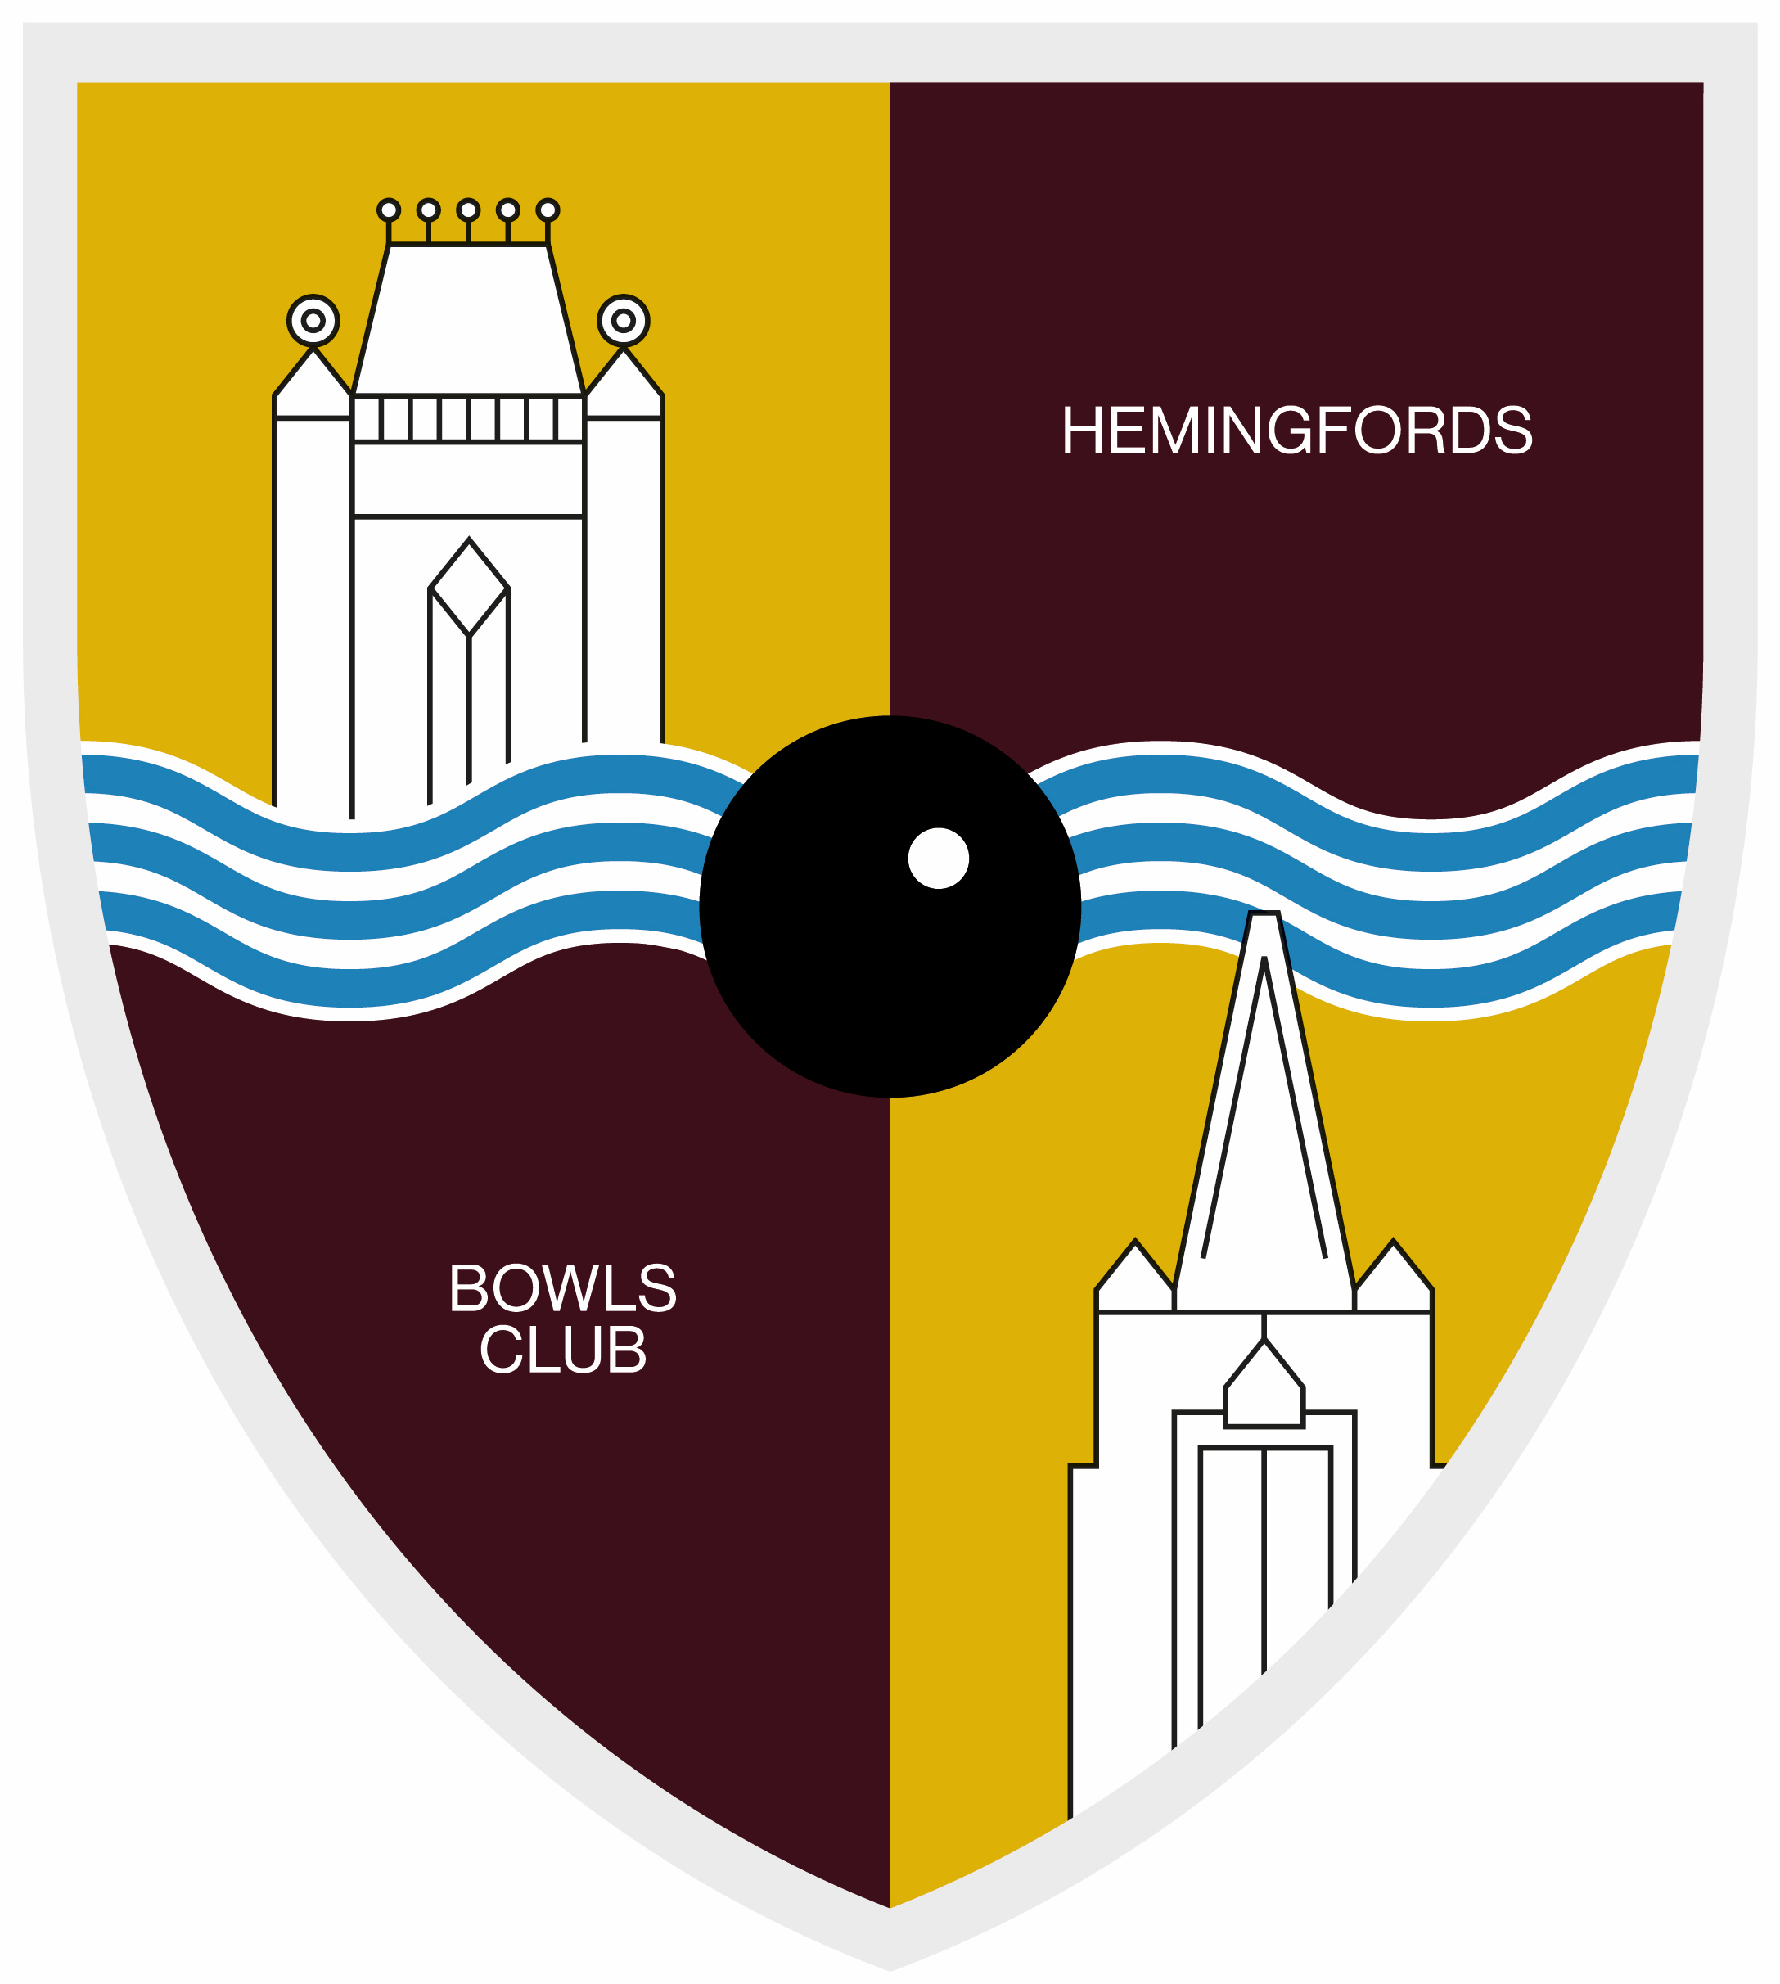
THE HEMINGFORDS BOWLS CLUB
ETIQUETTE

- Dress correctly for all games and arrive in good time
- Greet team members and opponents at the start of the game
- Congratulate or compliment them at the end of play
- Shake hands with everyone at the start of the game and at its conclusion
- Be aware of your role in the team – Lead (1), Second (2), Third (3) or Skip – and what that entails (see ‘Player Responsibilities’)
- Have your next bowl in your hand by the time the opposing player has delivered their bowl; scrambling around searching for your bowl is not acceptable, especially in a match
- When it is your turn to bowl, listen to your Skip’s directions and try to bowl to them
- It is a courtesy for the “Three” or middle player of the team who has won the previous end to place his/her skip’s bowl on the mat before joining the other players at change over

Concentrate fully on the game and all the bowls as they are delivered.
Remember you can pick up clues to how the green is behaving for when you bowl.
Follow how the head is building up so you do not have to ask other team members.

- Do not talk or make a noise behind the mat, or move at the head end, when a player is preparing to bowl
- Remain at least a metre behind the mat or behind the head until the player has bowled
- Remember that as soon as your bowl comes to rest, the possession of the rink (at both ends) passes to your opponents
- No bowls should be touched or moved until the end is declared
- Help clear the head after the result has been determined
- Avoid obscuring the rink number, rink edge markers or the Jack
- Keep to your own rink and walk quickly down the centre of your rink when changing ends
- Don’t walk past the end of a rink when someone is bowling towards your end or cut across a rink
- Make sure your shadow does not fall across the Jack, head or the mat

Do not criticise bowls - either from your own team or the other.
Congratulate an opponent on a well- played bowl and don’t grizzle if they have a lucky shot.
Show a good spirit - win well and lose well.

