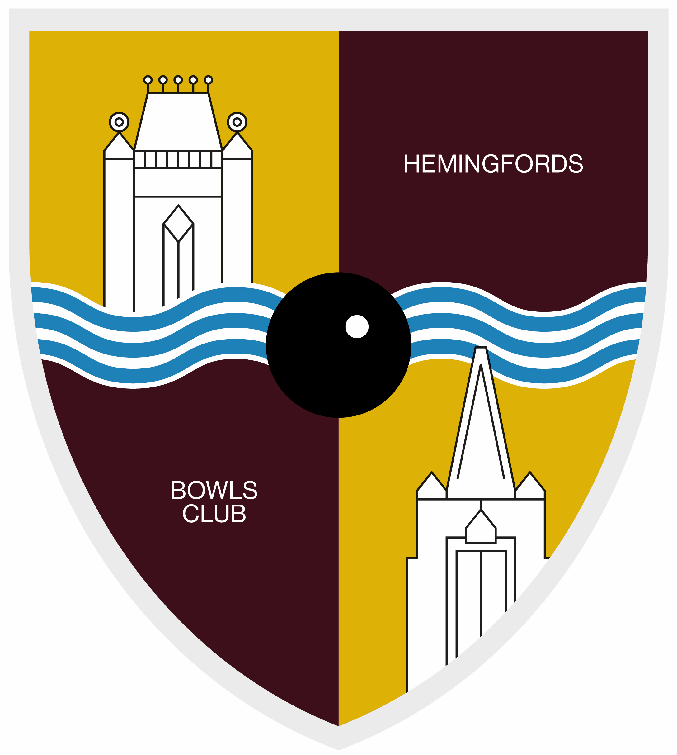
THE HEMINGFORDS BOWLS CLUB
FIRST AID POLICY

The Hemingfords Bowls Club (HBC) will ensure that there is adequate First Aid provision for their members’ health, safety and welfare.
The aim of First Aid is to reduce the effects of injury or illness suffered at the Club, therefore first aid provision must be adequate and appropriate to ensure that immediate assistance is given to causalities with both common injuries or illness and those likely to arise from specific hazards within the club and to summon an ambulance or other professional help i.e. a Medical Practitioner.
The policy applies to all members of HBC, visitors and contractors employed by HBC regardless of the cause.
TRAINING
The purpose of first aid training (Skills for Life) is to train people to deal safely and effectively with injuries or illnesses.
When selecting first aiders it is essential that only people who are reliable and likely to remain calm in an emergency be considered. There should be a commitment to undertake follow-up training as required.
The first aider should have the aptitude and ability to cope with training and be able to use the knowledge and skills learnt on the course. The duties can be physically demanding and first aiders should be free of any condition, which would affect their capability. It is also important that the first aider is able to leave whatever they are doing immediately and go rapidly to the scene of an emergency.
Those members who wish to be designated must have attended a Skills for Life course and obtain an approved certificate before practising as a First Aider. First aiders need to attend refresher training.
THE ROLE OF THE FIRST AIDER AT HBC
The First Aider can assess and treat minor injuries in the club until such time, if appropriate, that the injured member/visitor/contractor can be seen by their General Practitioner, attend an Urgent Care Centre or be treated by the Emergency Medical Services (EMS). They must be able to provide resuscitation should the need arise until EMS help arrives.
Should treatment involve bodily fluids, the waste must be disposed of correctly. All waste must be doubled bagged then disposed of in the main skip adjacent to the tennis courts.
The First Aider will have responsibility for the completion of an Incident Form in the First Aid Book for those incidents treated by the First Aider.

FIRST AID EQUIPMENT
It is the responsibility of HBC to ensure they have a First Aid box, which is easily accessible and clearly sited. The location of the First Aid Box is in the Clubhouse to the left of the entrance door. The First Aid Report Book is next to the First Aid Box. The First Aid Box will be equipped with suitable and sufficient quantities of First Aid supplies to meet the needs of the club. A First Aider will check the box monthly.
On initial qualification the First Aider is sent a certificate. A list of all First Aiders training is displayed in the Clubhouse.
THE RESPONSIBILITY OF HBC TO FIRST AIDERS
HBC First Aiders are volunteers. All members have access to the club at any time, therefore it must be stressed that no guarantee can be made that there will be a First Aider present in the club at any given time. Any activity undertaken is at the members’ own risk.
The First Aider will be available to give first aid to all when he/she is present in the club. The First Aider – who acts in good faith and within the scope of the expertise which has been gained by training – will, when giving first aid treatment, have the full support of HBC should the treatment given lead to subsequent criticism or prove detrimental to the individual receiving the first aid treatment.
HBC is of the opinion that “acting reasonably” and “in good faith” is interpreted in terms of good first aid standards and in the light of all prevailing circumstances.

Approval by Chairperson on behalf of the Committee of The Hemingford Bowls Club following submission and approval at the meeting held on

Date 8 April 2025

Signed S M Peel Chairperson

