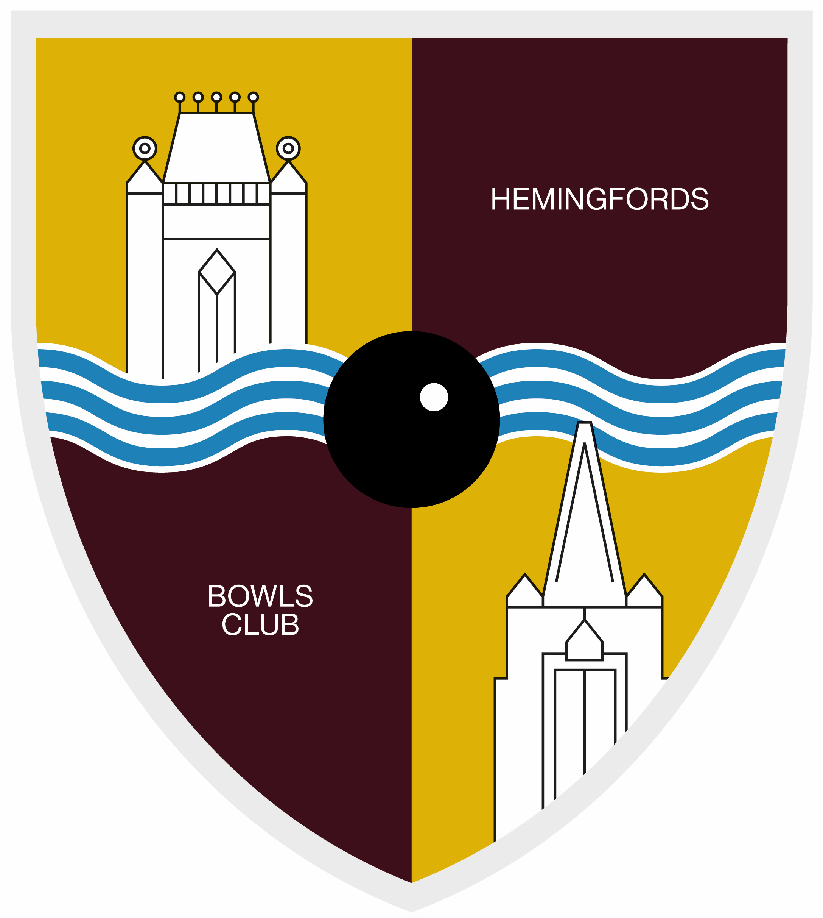
THE HEMINGFORDS BOWLS CLUB
EQUALITY AND DIVERSITY POLICY

The aim of this policy is to ensure that everyone is treated fairly and with respect and that members, non-members and visiting teams are not denied access to The Hemingfords Bowls Club because of a discriminatory reason.
This policy is fully supported by The Hemingfords Bowls Club Committee, which is responsible for the implementation and review of this policy.
The Hemingfords Bowls Club will therefore adhere to the following:
- be responsible for setting standards and values to apply throughout the place to play at every level, as lawn bowls should be enjoyed by everyone who wants to play the game;
- be committed to eliminate discrimination by reason of gender, sexual orientation, race, nationality, ethnic origin, religion or belief, ability or disability and to encourage equal opportunities;
- not discriminate or in any way treat anyone less favourably, on grounds of gender, sexual orientation, race, nationality, ethnic origin, religion or belief, ability or disability;
- ensure that it treats its members, non-members and visiting teams fairly and with respect and will ensure that all members of the community have access to and have opportunities to take part in, and enjoy, its programmes of activities, competitions and events;
- not tolerate harassment, bullying, abuse or victimisation of an individual (which the place to play/facility regards as forms of discrimination), including sexual or racially based harassment or other discriminatory behaviour, whether physical or verbal and work to ensure that such behaviour is met with appropriate action in whatever context it occurs;
- be committed to the immediate investigation of any complaints of discrimination on the above grounds, once they are brought to its attention. Complaints will be dealt with in accordance with its complaints policy and, where such a complaint is upheld, the committee may impose such sanction as it considers appropriate and proportionate to discriminatory behaviour;
- be committed to taking positive action where inequalities exist and the development of a programme of on-going training and awareness in order to promote the eradication of discrimination and to promote equality and diversity in lawn bowls;
- be committed to a policy of equal treatment of all members and employees and requires all members and employees to abide by and adhere to these policies and the requirements of the relevant equalities legislation, including the Race Relations Act 1976, Sex Discrimination Act 1975, Disability Discrimination Act 1995, Age Discrimination Act 2006 as well as any amendments to these acts and any new legislation.
In the event that any member, visitor or visiting team feels that he, she or it has suffered discrimination or harassment in any way or that the policies, rules or code of conduct have been broken they should follow the procedures below.
- The complainant should report the matter in writing to the Chairperson – Mrs Sue Peel, smpeel8159@gmail.com. The report should include:
- details of what occurred;
- details of when and where the occurrence took place;
- any witness details and copies of any witness statements;
- names of any others who have been treated in a similar way (provided that those people consent to their names being disclosed);
- details of any former complaints made about the incident, including the date and to whom such complaint was made; and
- an indication as to the desired outcome.
- If the person accused of discriminatory behaviour is a member or non-member, the committee or representatives of the committee:
- will request that both parties to the complaint submit written evidence regarding the incident(s);
- may decide (at its sole discretion) to uphold or dismiss the complaint without holding a hearing;
- may (at its sole discretion) hold a hearing (whether or not such a hearing is requested by either party) at which both parties will be entitled to attend and present their case;
- will have the power to impose any one or more of the following sanctions on any person found to be in breach of any policy, (including the Equality Policy):
      - warn as to future conduct;
      - suspend from membership;
      - remove from membership;
      - exclude a non-member from the facility, either temporarily or permanently; and
      - turn down a non-member’s current and/or future membership applications.
- will provide both parties with written reasons for its decision to uphold or dismiss the complaint within one calendar month of such decision being made.
- Either party may appeal a decision of the management committee to the County Association (including a decision not to hold a hearing) by writing to the [County Secretary] within 3 months of the place to play’s decision being notified to that party.

- If the nature of the complaint is with regard to the committee or other body or group in the place to play, the member/visitor has the right to report the discrimination or harassment directly to the relevant County Association.

Terminologies and Descriptors

Types of discrimination
There are three categories of discrimination: direct, indirect and positive:
- Direct discrimination is where a person, in a group of people with the same or similar circumstances, is treated less favourably than the others in the group because of their race, gender, disability or sexuality.
- Indirect discrimination occurs where the effect of certain requirements, provision or practices imposed by an organisation has an adverse impact disproportionately on one group or other. Indirect discrimination generally occurs when a rule or condition, which is applied equally to everyone, can be met by a considerably smaller proportion of people from a particular group; the rule is to their advantage and it cannot be justified on other grounds.
- Positive discrimination is in favour of those who were formerly discriminated against, especially in the provision of social and educational facilities and employment opportunities.
The Hemingfords Bowls Club will ensure that its members, volunteers, players and officials are not discriminated against on the basis of any of the following:
- race, colour, ethnic group or national origin
- gender or marital status
- disability
- sexuality or sexual orientation
- age
- employment status
- religion and faith
- unrelated criminal offences/ex-offenders (subject to any legal or public interest constraints)
- responsibilities for children or dependents
Harassment can be described as inappropriate actions, behaviour, comments or physical contact, which may cause offence i.e. mental or physical anxiety or hurt to an individual:
- It may be related to gender, race disability, sexuality, age, religion, nationality or any personal characteristic of an individual.
- Under the terms of the Criminal Justice Act 1994, harassment was made a criminal offence, punishable by a fine of up to £5,000 and/or a prison sentence of up to six months.
Victimisation can be described as treating an individual less favourably than one would treat others because the individual has made a complaint of discrimination, given evidence about such a complaint or raised a concern under the Public Interest (Disclosure) Act 1998.
‘Positive action’ refers to a number of methods designed to counteract the effects of discrimination and to help eradicate stereotyping. It can be initiatives or activities that attempt to redress imbalances by providing extra help, doing things in a different way or promoting opportunities in targeted places and to targeted groups. Under this broad meaning, positive action may include actions such as the introduction of discriminatory selection procedures, and training programmes or policies aimed at preventing sexual harassment. An example of positive action being taken is the employment of a female coach to lead a session aimed at women, to specifically encourage uptake and participation by female players.
Prejudice is literally pre-judging someone. It is usually led by negative, irrational feelings, resulting from preconceived attitudes and opinions.
Stereotyping is grouping or labelling people because they are members of a particular ‘visible’ group, and assuming that they have particular traits that are considered to be characteristics of that group.
Dignity is about respectful, responsible, fair and humane behaviour, something that is reflected in the constitution.
Disadvantage is where, as a result of discrimination, an individual or group is deprived of some or all resources and opportunities. This may affect people directly or indirectly.
Social exclusion is when people or areas suffer from one or a combination of linked problems such as unemployment, poor skills, low income, high crime environments or lack of facilities.
Approval by Chairperson on behalf of the Committee of The Hemingfords Bowls Club following submission and approval at the meeting held on

Date 08.04.2025

Signed S M Peel Chairperson

